ME 200 – Thermodynamics, L. Liebenberg

**Name:** Joseph Specht **Net-ID:** jspecht3

**Quiz 6** (Total: 20 points) **Due back by Wed. March 1 at 10 p.m., in Canvas**

* *Assignments will only be graded if the honor code statement is completed and signed.*
* *Save your entire assignment as one* ***PDF document*** *and upload it in the appropriate assignment folder on Canvas.*

**Honor Code Statement**

***ME 200, Quiz 6***

Being a student of high standards, I pledge to embody   
the principles of *academic integrity*.

This quiz is my own work. I did not seek (or get) outside help or collaboration with any of the questions and their solutions. I did not post any of the questions on an electronic platform (like Chegg) nor did I solicit answers or solutions from any electronic platform (like Chegg). I also did not offer my solutions or answers to any other student.

I understand that this quiz is “open book” and “open notes” which means that I was permitted to use my prescribed textbook and lecture notes when addressing any of the questions. I have properly cited any other resources, with full cognizance of the regulations pertaining to plagiarism, copyright infringement, academic cheating, etc., as stipulated in the Student Code.

I acknowledge that academic violations will be dealt with according to the UIUC Student Code,   
Article 1, Part 4.



Student’s signature:________________________________________________________________

Student’s Name: Joseph F. Specht

Net-ID: jspecht3

Date: 2/28/2023

1. A picture containing engine

   Description automatically generatedA desktop computer must be cooled by a fan (also known as a “CPU fan”) that maintains a volumetric flow rate of 0.34 m3/min.
2. Determine the mass flow rate (in kg/s) of the air through the fan at an elevation of   
   3400 m where the air density is 0.7 kg/m3. *(5 points)*

We know mass flow rate is dm/dt = rho_density * Area * dx/dt. The change in Area * dx/dt is equal to the volumetric flow rate.

Therefore, dm/dt = d~~V~~/dt * rho_density

$$\frac{dm}{dt}=\frac{dV}{dt}*ρ_{density}=.34\frac{m^{3}}{min}*.7\frac{kg}{m^{3}}=.00566\frac{m^{3}}{sec}*.7\frac{kg}{m^{3}}=.00397\frac{kg}{s}$$

.00397 kg/s is dm/dt.

1. If the average velocity of air must not exceed 110 m/min, determine the required diameter of the fan (in mm). *(5 points)*

Since d~~V~~/dt is equal to .34 m^3/min and this is also equal to A * dv/dt. The follow equation must be true…

$$.34\frac{m^{3}}{min}=A*\frac{dv}{dt}=A*110\frac{m}{min}$$

Since this is a circle, we also know that A = pi*d^2/4

$$∴A=\frac{.34}{110}m^{2}=π*\frac{d^{2}}{4}$$

$$d^{2}=.00309m^{2}*\frac{4}{π}=.003935m^{2}$$

$$d=\sqrt{.003935m^{2}}=.0627m=62.733mm$$

The diameter is 62.733mm.

1. 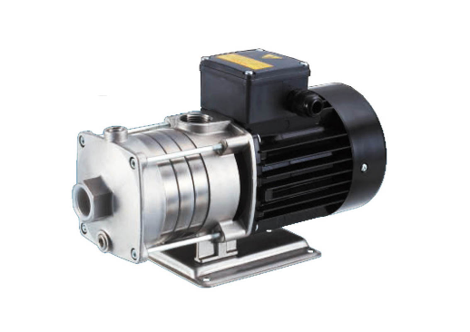An electrically driven pump increases water pressure from 100 kPa at the inlet to 900 kPa at the outlet. Water enters the pump at 15ºC through a 10-mm diameter opening and exits through a 15-mm diameter opening.
   1. Determine the velocity (in m/s) of the water at the inlet and outlet when the mass flow rate through the pump is 0.5 kg/s. *(8 points)*

dm/dt = rho * A * V = A * V / ~~v~~

With this we can assume that the specific volume for water is 1/density, which lets us solve for velocity. We also know water in effectively incompressible, so we can simply use the temperature to find the specific volume from table A-2.

$$A_{1}=π*\frac{D_{1}^{2}}{4}=π*\frac{10mm^{2}}{4}=π*\frac{(.010m)^{2}}{4}= 7.854*{10}^{-5}{ m}^{2}$$

$$A_{2}=π*\frac{D_{2}^{2}}{4}=π*\frac{15mm^{2}}{4}=π*\frac{(.015m)^{2}}{4}= 1.7671*{10}^{-4}{ m}^{2}$$

With the areas, we can solve the equation by plugging in each value.

$$\frac{dm}{dt}=\left(\frac{1}{v_{f}}\right)*A*V=\left[\frac{kg}{m^{3}}*m^{2}*\frac{m}{s}\right]=\left[\frac{kg}{s}\right]=\frac{.5kg}{s}$$

$$\frac{.5kg}{s}*\frac{1.0009*{10}^{-3} m^{3}}{kg}=\frac{5.0045*{10}^{-4}{ m}^{3}}{s}=A*V$$

$$V=\frac{5.0045*{10}^{-4}m^{3}}{s}*\frac{1}{A}$$

Solving…

* 1. What are these velocities (in m/s) if the inlet temperature is raised to 40ºC? *(2 points)*

We can then just change the specific volume for that of subcooled water at 40*C.

$$V=\frac{.5kg}{s}*\frac{1.008*{10}^{-3} m^{3}}{kg}*\frac{1}{A}$$

Plugging these in for the areas of each opening we get…

$$V_{1}=\frac{.5kg}{s}*\frac{1.008*{10}^{-3} m^{3}}{kg}*\frac{1}{7.854*{10}^{-5}{ m}^{2}}=6.417\frac{m}{s}$$

$$V_{2}=\frac{.5kg}{s}*\frac{1.008*{10}^{-3} m^{3}}{kg}*\frac{1}{1.7671*{10}^{-4}{ m}^{2}}=2.852\frac{m}{s}$$